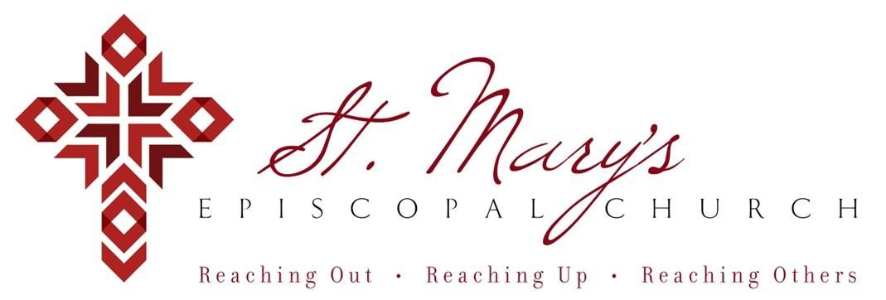

 Welcome to St. Mary’s! If you are new to our parish, you may use your smartphone’s camera to open the QR Code. This will allow you to let us know that you were here. We will send you a return email, but we will not add you to any mailing list unless you explicitly ask to be added. Thank you for blessing us with your presence. Please come share some coffee or tea and conversations in the Parish Hall today after the 10a.m. service.

Receiving Communion

All who claim Christ as Lord are always invited to receive communion in this Parish.

Weekly Prayers: May 31, 2026
Our Cycle of Prayer
Please pray for St. Philip’s, Ardmore Ardmore Village, Ardmore Eglise Anglicane du Rwanda, Poulson, our Diocesan Bishop; and for Daniel, Bishop of our Companion Diocese of Uruguay and the Presiding Bishop, Sean Rowe, Sarah, The Archbishop of Canterbury. For our interim Rector, The Rev’d Nancy Cox.

We give thanks for the Gray, Grellner, and Grillot families.

For those in need:
Debbie, Pam, Edith, Tookie, Roy

For those who have died:
Dick, Carol, Annette

CHRISTIAN FORMATION:
Wired Word
9:00 a.m. each Sunday

Men’s Study Group
Meeting Thursday’s at 7:00pm
Please join us in the faith development of the Church.
TOPIC - Parables - The Mysteries of God's Kingdom Revealed through the Stories Jesus Told.
Author - John MacArthur

Children’s Formation
9:00a.m. each Sunday

MUSIC for Sunday, 5/31/26:

H 362 processional hymn
H 405 offertory hymn
H 131 communion hymn
WLP 778 processional hymn

Choir & Childrens Formation
We are taking a break for the summer months. See you again in September!

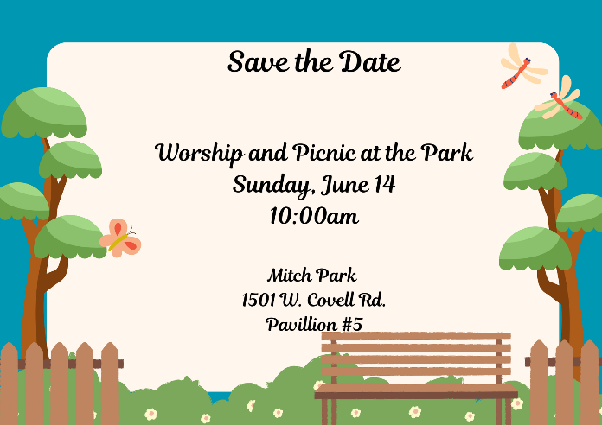

This will be the only service on June 14th. Please join us at 10am in Mitch Park and bring a friend or two!
 Support St. Mary’s Church

BASEBALL
Save The Date
Friday, July 10th

7:05pm Comets vs. El Paso Chihuahuas at the Chickasaw Bricktown Ballpark. $28.00 per ticket, all you can eat with soda and water. Gather your family and friends and reserve your seats for this fun night out.


Volunteer Opportunity
Saturday, July 11th
Regional Food Bank of OKC

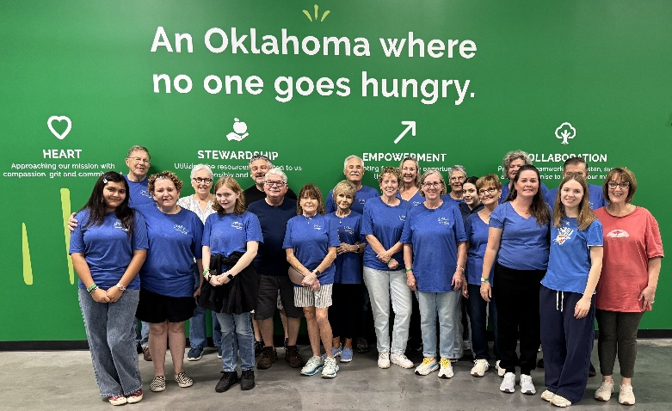
8:30a.m. to noon shift with 25 spots available to sign up. Join us if you can and help give back to our community!


Join us weekly for Sunday Service at 8a.m. and 10a.m. ~ St. Mary’s 405-341-3855

